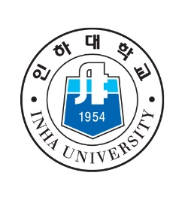
FINANCIAL DOCUMENTATION REQUIREMENT
COVERSHEET OF Bank/Sponsor STATEMENT for Incoming Student

The Korean Immigration Service requires all international students to prove that they have adequate funding to support all expenses depending on the period of study.

I. CERTIFICATION OF AGREEMENT BY STUDENT
Please read all of the statements below and check the boxes as an indication that you understand the accompanying statement:
□ I understand that my sponsors and I will be responsible for the costs of my travel fee and living costs at INHA.
□ I understand that some costs (housing, Insurance) may increase during my time at INHA.
Name as Printed on Your Passport (Please print and underline last or family name)
Signature Date.

II. CERTIFICATION OF AGREEMENT BY SPONSOR (If you are self-supported, leave this part as blank.)
This is to certify that I have read the information provided on this form and assume financial responsibility for the student.
Name of Sponsor or Agency (please print)
Relationship to Student
Phone Number of Sponsor Email
Signature of Sponsor Date

III. CONFIRMATION by HOME UNIVERSITY (*Important)
*I confirm that the student above has enough bank statement for the period of study (□ one semester, □ 1 year. – Please check the checkbox) guided by INHA.

IMPORTANT!! (minimum amount for one semester: more than USD 5500, 1 year: more than USD 7500)
Official’s Name (please print)

Official’s Title
International Officers’ Stamp/or Signature

