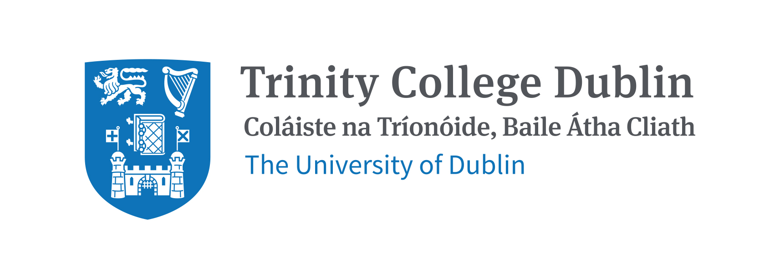

**Application guide for prospective HIT-TCD students**

**The key application notices:**

 • Students should submit their postgraduate application to Trinity before application deadline of 2025. Deadlines vary from course to course, please check www.tcd.ie/courses/postgraduate/ to see what is the deadline for your preferred programme.

• Student should submit the ‘Partnership Declaration Form’ when applying to ensure the eligibility for the HIT-TCD special scholarship. Scholarship application will not be processed without Partnership Declaration Form.

• HIT to nominate special scholarship students to Trinity

# How to Apply

An application can be created in Trinity's my.tcd.ie portal in a few simple steps.

1. Go to the [Courses](https://www.tcd.ie/courses/postgraduate/faculty/) website and find the course you love. *www.tcd.ie/study/apply/making-an-application/postgraduate/index.php*
2. Read the [User Guide](https://www.tcd.ie/study/assets/PDF/User-guide-%20PG-application.pdf) for my.tcd.ie applications. *www.tcd.ie/study/assets/PDF/User-guide-%20PG-application.pdf*
3. Apply by selecting the 'Apply' link under the course description. You can save your application and return to it, but remember to submit it when you're finished!

An application fee of €55 is applicable for all direct applications to Trinity College Dublin. This payment must be made online following the instructions on the application form. The online application processing fee is non-refundable. The course application will not be submitted to Trinity until the application fee is paid in full.

**As part of the online application, applicants will also need to submit original or certified true* copies of:**

• Third level qualification results

• IELTS, Cambridge Advanced/Proficiency, TOEFL, Duolingo scores, for applicants whose first language is not English

• Academic transcripts for each year of third level study and all third level qualifications awarded

• Two letters of recommendation

• Passport

• Application fee (non-refundable)

Please note that where the statement of examination results is in a language other than English, applicants should submit a certified true translation of the statement along with a certified true copy of their original results with the application.

*A certified true copy is a photocopy of an original document that has been signed and stamped by a school principal or other official.

More info : <https://www.tcd.ie/study/apply/making-an-application/postgraduate/index.php>